**STUDENT MANAGEMENT PORTAL**

**REACT**

Vaishnavi

25/7/2025

This project demonstrates a basic React application that includes multiple components: **Home**, **About**, and **Contact**. It is a simple starting point for building a **Student Management Portal**, showcasing how components work together in a React app.

**Objective:**

* Understand how to create and use class-based components in React.
* Learn how to structure a multi-page interface using React components.
* Display different sections (Home, About, Contact) within a single page.
* Apply basic styling using CSS.

**Implementation:**

**Step 1: Create a React App**

Open the terminal and create a new React app:



Navigate



**Step 2: Create Component Files**

Inside the src folder, create a Components folder and add three files:

* Home.js
* About.js
* Contact.js

**Home.js**

import React from 'react';

class Home extends React.Component {

render() {

return (

<div>

<h2>Welcome to the Home page of Student Management Portal</h2>

</div>

);

}

}

export default Home;

**About.js**

import React from 'react';

class About extends React.Component {

render() {

return (

<div>

<h2>Welcome to the About page of the Student Management Portal</h2>

</div>

);

}

}

export default About;

**Contact.js**

import React from 'react';

class Contact extends React.Component {

render() {

return (

<div>

<h2>Welcome to the Contact page of the Student Management Portal</h2>

</div>

);

}

}

export default Contact;

**Step 3: App Component**

Open App.js and replace it with:

import './App.css';

import About from './Components/About';

import Contact from './Components/Contact';

import Home from './Components/Home';

function App() {

return (

<div className="Container">

<Home />

<About />

<Contact />

</div>

);

}

export default App;

**Step 5: Run the App**



It will show all three components rendered on the same page, each displaying a welcome message for different sections of the Student Management Portal.

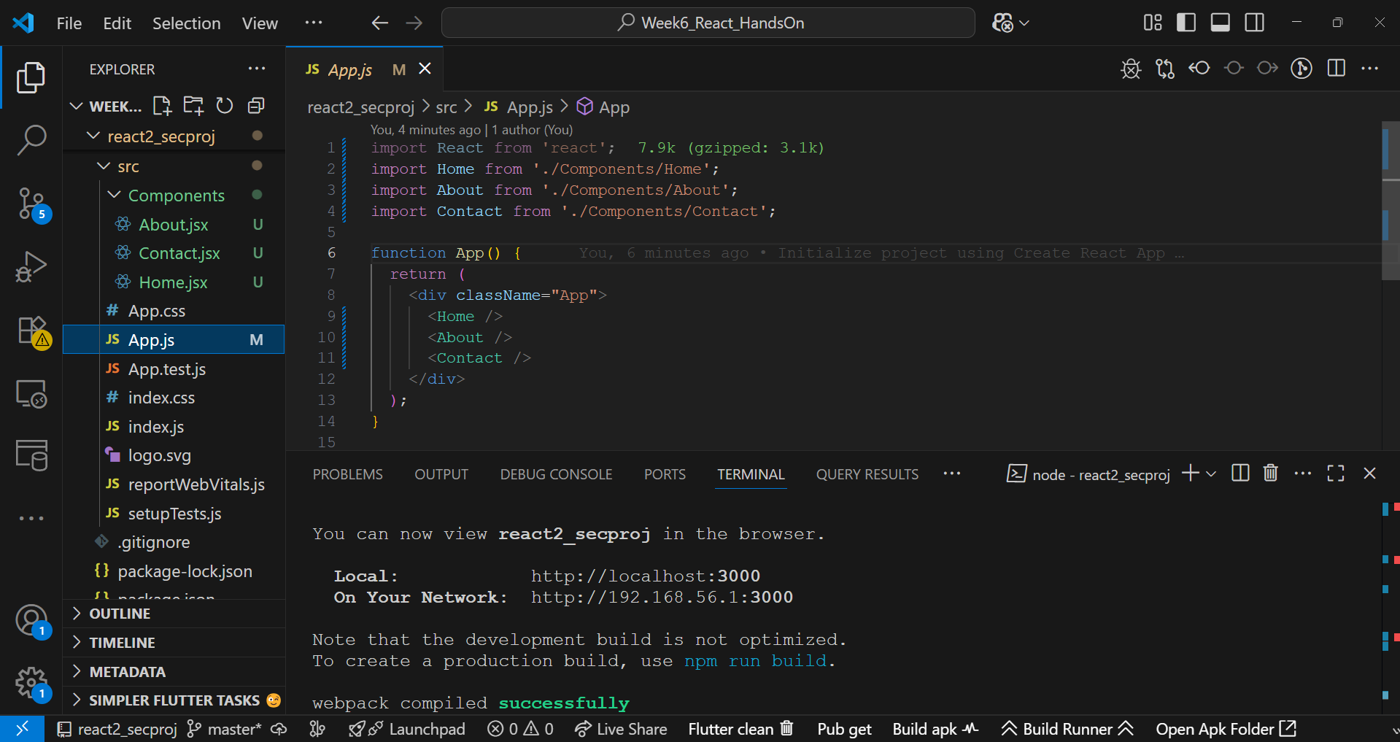

**Output:**

